San Diego Marriott Mission Valley Property Map

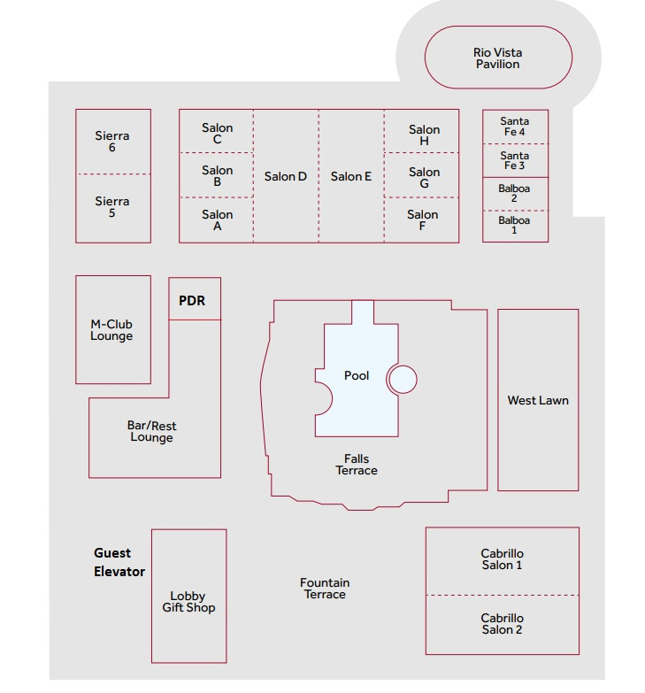

Self-Parking

Elite Parking

Front Drive