Management representation letter - nonprofit - DAR 7/9/16 [1] [2] [3] [4] [5]

Please read the guidance in endnote 2 for information to help you efficiently use this new CLA template.

March 1, 2018

CliftonLarsonAllen LLP

2210 E Rte 66

Glendora, CA 91740

This representation letter is provided in connection with your audit of the financial statements of California-Nevada-Hawaii District of Kiwanis International, which comprise the statements of financial position[6] as of September 30, 2017 and 2016[7], and the related statements of OR activities and cash flows[8] for the years then ended, and the related notes to the financial statements, for the purpose of expressing an opinion on whether the financial statements are presented fairly, in all material respects, in accordance with accounting principles generally accepted in the United States of America (U.S. GAAP).[9]

Certain representations in this letter are described as being limited to matters that are material. Items are considered material, regardless of size, if they involve an omission or misstatement of accounting information that, in light of surrounding circumstances, makes it probable that the judgment of a reasonable person relying on the information would be changed or influenced by the omission or misstatement.

We confirm, to the best of our knowledge and belief, as of March 1, 2018[10], the following representations made to you during your audits.

Financial Statements

* We have fulfilled our responsibilities, as set out in the terms of the audit engagement letter dated February 14, 2017, for the preparation and fair presentation of the financial statements in accordance with U.S. GAAP.[11]
* We acknowledge and have fulfilled our responsibility for the design, implementation, and maintenance of internal control relevant to the preparation and fair presentation of financial statements that are free from material misstatement, whether due to fraud or error.
* We acknowledge our responsibility for the design, implementation, and maintenance of internal control to prevent and detect fraud.
* We acknowledge our responsibility for the design, implementation, and maintenance of internal control over the receipt and recording of contributions.
* Significant assumptions used by us in making accounting estimates are reasonable.[12] [13]

Alternate wording

* Related party relationships and transactions have been appropriately accounted for and disclosed in accordance with the requirements of U.S. GAAP.[14]
* No events have occurred subsequent to the financial statement date and through the date of this letter that would require adjustment to, or disclosure in, the financial statements.[15]
* We have not identified or been notified of any uncorrected financial statement misstatements.
* We are not aware of any pending or threatened litigation, claims, or assessments or unasserted claims or assessments that are required to be accrued or disclosed in the financial statements in accordance with U.S. GAAP, and we have not consulted a lawyer concerning litigation, claims, or assessments.
* Designations of net assets, or reclassifications of net assets, have been properly authorized, approved, and reflected in the financial statements.
* The cost allocation methods used to allocate the entity’s expenses to the appropriate functional classification as program services, management and general, and fundraising are properly supported by the entity’s books and records. The cost allocation methods used are rational, systematic, and consistently applied. The bases used for allocation of functional expenses are reasonable.[16]

Information Provided

* We have provided you with:
  + Access to all information, of which we are aware, that is relevant to the preparation and fair presentation of the financial statements such as records, documentation, and other matters.
  + Additional information that you have requested from us for the purpose of the audit.
  + Unrestricted access to persons within the entity from whom you determined it necessary to obtain audit evidence.
  + Complete minutes of the meetings of the governing board and related committees, or summaries of actions of recent meetings for which minutes have not yet been prepared. If none, use the next bullet instead.
* There have been no communications from regulatory agencies concerning noncompliance with, or deficiencies in, financial reporting practices.
* All transactions have been recorded in the accounting records and are reflected in the financial statements.[17]
* We have disclosed to you the results of our assessment of the risk that the financial statements may be materially misstated as a result of fraud.
* We have no knowledge of any fraud or suspected fraud that affects the entity and involves:[18]
  + Management;
  + Employees who have significant roles in internal control; or
  + Others when the fraud could have a material effect on the financial statements.
* We have no knowledge of any allegations of fraud, or suspected fraud, affecting the entity's financial statements communicated by employees, former employees, grantors, regulators, or others.[19]
* We have no knowledge of any instances of noncompliance or suspected noncompliance with laws and regulations and provisions of contracts and grant agreements, or abuse whose effects should be considered when preparing financial statements.
* We are not aware of any pending or threatened litigation, claims, or assessments, or unasserted claims or assessments, that are required to be accrued or disclosed in the financial statements in accordance with U.S. GAAP, and we have not consulted a lawyer concerning litigation, claims, or assessments.
* There are no other material liabilities or gain or loss contingencies that are required to be accrued or disclosed in accordance with U.S. GAAP.
* We have disclosed to you the identity of the entity's related parties and all the related party relationships and transactions of which we are aware.[20]
* The entity has satisfactory title to all owned assets, and there are no liens or encumbrances on such assets, nor has any asset been pledged as collateral, except as made known to you and disclosed in the financial statements.
* We are responsible for compliance with the laws, regulations, and provisions of contracts and grant agreements applicable to California-Nevada-Hawaii; and we have identified and disclosed to you all laws, regulations, and provisions of contracts and grant agreements that we believe have a direct and material effect on the determination of financial statement amounts or other financial data significant to the audit objectives.
* We have complied with all restrictions on resources (including donor restrictions) and all aspects of contractual and grant agreements that would have a material effect on the financial statements in the event of noncompliance. This includes complying with donor requirements to maintain a specific asset composition necessary to satisfy their restrictions.
* California-Nevada-Hawaii District of Kiwanis is an exempt organization under Section 501c4 of the Internal Revenue Code. Any activities of which we are aware that would jeopardize the entity’s tax-exempt status, and all activities subject to tax on unrelated business income or excise or other tax, have been disclosed to you. All required filings with tax authorities are up-to-date.
* We are responsible for determining whether we have received, expended, or otherwise been the beneficiary of any federal awards during the period of this audit. No federal award, received directly from federal agencies or indirectly as a subrecipient, was expended in an amount that cumulatively totals from all sources $750,000 or more. For this representation, “award” means financial assistance and federal cost-reimbursement contracts that non-federal entities receive directly from federal awarding agencies or indirectly from pass-through entities. It does not include procurement contracts, user grants, or contracts used to buy goods or services from vendors.
* As part of your audit, you prepared the draft financial statements and related notes. We have designated an individual who possesses suitable skill, knowledge, and/or experience to understand and oversee your services; have made all management judgments and decisions; and have assumed all management responsibilities. We have evaluated the adequacy and results of the service. We have reviewed, approved, and accepted responsibility for those financial statements and related notes.
* In regards to the tax return preparation services performed by you, we have:[21]
  + Made all management judgments and decisions and assumed all management responsibilities.
  + Designated an individual who possesses suitable skill, knowledge, or and/or experience to understand and oversee the services.
  + Evaluated the adequacy and results of the services performed.
  + Accepted responsibility for the results of the services.

Signature: Title: [22]

[INSERT ATTACHMENT RELATED TO PASSED ADJUSTMENTS IF APPLICABLE]

1. All listed representations should be included in the letter unless not applicable. Yellow shaded text indicates text which may or may not be needed in the specific client circumstances. Edit, retain, or delete as appropriate for the client. Additional representations should be added to address significant or unusual matters.
2. Template letter functionality 

   Five icons were added to the Word quick access toolbar for this template to help you efficiently use it.

   Since computers have different default settings, you may need to change your settings. Click on “Options"  on the quick access toolbar. Ensure “Hidden text” and “Print hidden text” are unchecked.

   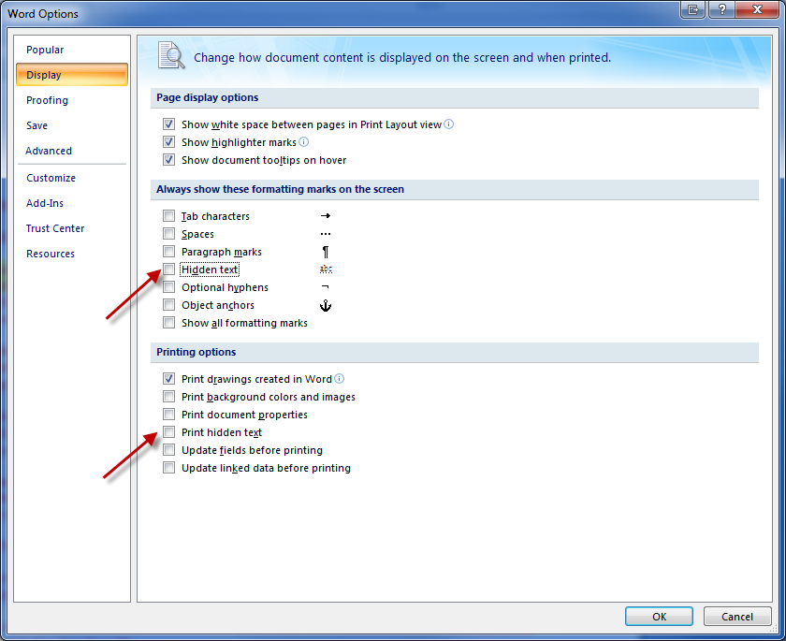

   Red text identifies informational (hidden) text. Click on “Show/Hide”  on the quick access toolbar to show or hide hidden text. Hidden text will not print.

   Yellow shaded text indicates text which may or may not be needed in the specific client circumstances. Edit, delete, or retain as appropriate for the client.

   Endnotes include hidden text. If you want to view the endnote popup, click “Options”  on the quick access tool bar, and check “Hidden text” in the “Always show these formatting marks on the screen” section. You will need to uncheck again to hide the text if you want to view the text in order to insert appropriate page breaks before printing.

   Click on shaded form fields and type appropriate text. (This replaces the content and eliminates the form field.) Alternatively, click “Lock”  in the quick access toolbar to lock the document so you may tab through the form fields in the document to edit the text in the form fields. The locking feature can be toggled on and off with this icon. (Use Shift + Tab to move to the previous field.)

   Styles can be used to efficiently format added content copied from another document. (Styles are available on the Home ribbon.) Styles can be used to efficiently change optional text to hidden text to exclude from the letter for the current period but retain for evaluation in subsequent periods. (Use Word’s “Bullets” feature as needed.)

   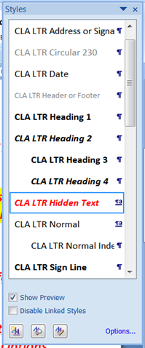

   Printing:

   * Letters should be printed and provided to the client for copying on client letterhead and signature. If sending electronically, print to Adobe. Ensure the appropriate margins are used to provide adequate space for client letterhead.
   * Complete the date in the header field on the second page.
   * Yellow highlighting needs to be eliminated before printing. From the “Home” ribbon, choose “Select” and “Select All,” to highlight the content of the entire letter; then click on the “Text Highlight Color”  arrow on the quick access toolbar and choose “No Color.”
   * Click “Form Field Shading”  on the quick access toolbar to eliminate field shading before printing.
   * If hidden text is printing, click on “Options”  and uncheck “Print hidden text” under “Printing options.”

  
3. This letter has been updated for the clarified auditing standards and is based on AU-C 580, Written Representations. PPC’s practical considerations can be viewed on RIA Checkpoint, letter CL-3.6.
4. If management refuses to provide required written representations, or if we have concluded that sufficient doubt exists about management’s integrity such that the representations are not reliable, we should disclaim an opinion on the financial statements or withdraw from the engagement.
5. The following are representations that may need to be added to the letter to appropriately tailor it for individual client circumstances (list is not all-inclusive). Wording for some of these items is included in the second to last endnote.

   Contributions

   * Contributed services that are or are not required to be recorded as contributions under FASB ASC 958-605 .
   * The adequacy of the organization’s internal controls over contributions.
   * The organization’s reasons for not confirming with a particular donor.

   Expenses for Program and Supporting Services

   * The organization’s reasons for conducting activities that have elements both of program services and fund-raising.
   * Matters related to joint activities such as the completeness of joint activities tested, the rationale for selecting the audience for the joint activities, and the appropriateness of the cost allocation methods.
   * Reasonableness of bases for allocation of functional expenses.

   Property and Equipment

   * The historic or cultural value of individual works of art or historical treasures and the organization’s technical and financial ability to preserve the items as a condition for not depreciating them.

   Prepaids, Deferred Charges, Intangibles, and Other Assets

   * Impairment of goodwill and other intangible assets not subject to amortization.
   * Material deferred charges.

   Investments and Derivatives

   * Existence and completeness of derivatives and appropriate characteristics of hedges.
   * Unusual considerations involved in determining the application of the equity method of accounting.
   * The organization’s interpretation of applicable laws over unrealized gains on endowments; that is, whether donor restrictions extend to the net appreciation on the endowment investments.

   Income Taxes

   * Aggressive tax elections or uncertain tax positions.
   * IRS examinations or other matters.
   * Provision for unpaid unrelated business income taxes.

   Accounts Payable and Other Liabilities

   * Contributions to employee benefit plans or bonuses not documented in the minutes.
   * Pension payments made after the client’s year end.
   * Actuarial assumptions used to measure pension liabilities and costs are appropriate.
   * Expected employer contributions to defined benefit pension and postretirement benefit plans for the next fiscal year, if material to the financial statements.

   Notes Payable and Long-term Debt

   * Management has the intent and ability to refinance short-term debt on a long-term basis.

   General

   * A national organization’s recording (or disclosing to the auditor) of all transactions with its controlled affiliate organizations.
   * Actions allowed by funding sources or regulatory agencies that are not documented in writing or by legal references.
   * Acknowledgement of oral communications made by the auditor.
   * Transactions for which there is no written supporting documentation.
   * Representations needed for a specialized industry.
   * Actions allowed by regulatory agencies that are not documented in writing or by legal references.
   * GAAP changes/adoption.
   * Use of a specialist.
   * Restatement made to correct a material misstatement in a prior period that affects the comparative financial statements. (AU 700.52)
   * Financial instruments with concentration of credit risk.
   * Future plans or commitments.
   * Lawsuits, regulatory actions, etc.
   * Environmental remediation liabilities and related loss contingencies.
   * Other representations relied on during the audit. (It may be helpful to maintain in the workpapers a list of client representations relied on during the audit.)

   Other (AU 580.A18 and A19.)

   * Whether the selection and application of accounting policies are appropriate
   * Whether matters such as the following, when relevant under the applicable financial reporting framework, have been recognized, measured, presented, or disclosed in accordance with that framework:
     + Plans or intentions that may affect the carrying value or classification of assets and liabilities
     + Liabilities, both actual and contingent
     + Title to, or control over, assets and the liens or encumbrances on assets and assets pledged as collateral
   * Aspects of laws, regulations, and contractual agreements that may affect the financial statements, including noncompliance.
   * Whether management has communicated to the auditor all deficiencies in internal control of which management is aware.

  
6. Use exact statement titles.
7. According to AU-C 580, Written Representations, representation letters should include all periods covered by the auditors’ report.
8. Use exact statement titles. For a voluntary health and welfare organization, use the wording “activities, functional expenses, and cash flows.” For an organization other than a voluntary health and welfare organization, use the wording “activities and cash flows.”
9. Modify if the applicable reporting framework is not U.S. GAAP.
10. This is linked to the “Charge code” in the binder properties.
11. Modify if the applicable reporting framework is not U.S. GAAP.
12. According to AU-C 540.A126, Auditing Accounting Estimates, Including Fair Value Accounting Estimates, and Related Disclosures, audit evidence can include obtaining representations from management about whether it believes that the significant assumptions used in making accounting estimates are reasonable. Additionally, according to AU-C 580.A13, such written representations might address the following:

    * The appropriateness and consistency of the measurement processes used by management in determining accounting estimates.
    * That the assumptions appropriately reflect management’s intent and ability to carry out specific courses of action.
    * That the disclosures related to accounting estimates are complete and appropriate.
    * That no subsequent event has occurred that would require adjustment to the accounting estimates or disclosures included in the financial statements.

   
13. AU-580.A14 states that for those accounting estimates not recognized or disclosed in the financial statements, written representations also may include representations about the following:

    * The appropriateness of the basis used by management for determining that the criteria of the applicable financial reporting framework for recognition or disclosure have not been met.
    * The appropriateness of the basis used by management to overcome a presumption relating to the use of fair value set forth under the entity's applicable financial reporting framework for those accounting estimates not measured or disclosed at fair value

   
14. Modify if the applicable reporting framework is not U.S. GAAP.
15. AU-C 560, Subsequent Events and Subsequently Discovered Facts, addresses circumstances when the auditor includes an additional date on the auditors’ report (that is, dual-dates the auditors’ report for a revision relating to a subsequent event). In such circumstances, the auditor may determine that obtaining additional representations relating to the subsequent event is appropriate. (AU-C 560.13)

    If a subsequent event has been disclosed in the financial statements, this item may be modified to begin, “Except as disclosed in Note X to the financial statements, . . .”
16. List other appropriate representations related to the financial statements. See also the second to last endnote for examples from AU-C 580, Exhibit B.
17. Management's representations may be limited to matters that are considered either individually or collectively material to the financial statements, provided management and the auditor have reached an understanding on materiality for this purpose. (AU-C 580.A22)
18. The wording of this representation may need to change, when necessary, to say “Except as disclosed to you, . . .”
19. The wording of this representation may need to change, when necessary, to say “Except as disclosed to you, . . .”

    The item could be modified as follows: “Except for the allegation discussed in the minutes of the November 16, 20X1 meeting of the board of directors (or disclosed to you at our meeting on November 16, 20X1), we have no knowledge of any allegations of fraud, or suspected fraud affecting, the entity’s financial statements received in communications from employees, former employees, grantors, regulators, or others..”
20. AU 580.A15 identifies circumstances in which it may be appropriate to obtain written representations about related parties from those charged with governance in addition to management include the following:

    * When they have approved specific related party transactions that (a) materially affect the financial statements or (b ) involve management
    * When they have made specific oral representations to the auditor on details of certain related party transactions
    * When they have financial or other interests in the related parties or the related party transactions

    In addition, AU 580.A16 states the auditor also may decide to obtain written representations regarding specific assertions that management may have made, such as a representation that specific related party transactions do not involve undisclosed side agreements.
21. Ethics Interpretation 101-3, Performance of Nonattest Services, requires the client to assume all management responsibilities in connection with nonattest services. If applicable, consider including this representation. Modify as appropriate. Omit if not applicable.
22. The representation letter should be signed by members of management that have overall responsibility for financial and operating matters and knowledge of the matters covered by the representations. This normally includes the executive director and chief financial officer or other equivalent persons for entities that do not use such titles. (AU-C 580.A2)

    For small nonprofit organizations, the representation letter is generally signed by the current executive director. If the small nonprofit organization has a controller or chief financial officer, the auditor might consider having that person sign the letter also. Also, it is not unusual to obtain separate representations from board members on certain matters such as related party transactions.